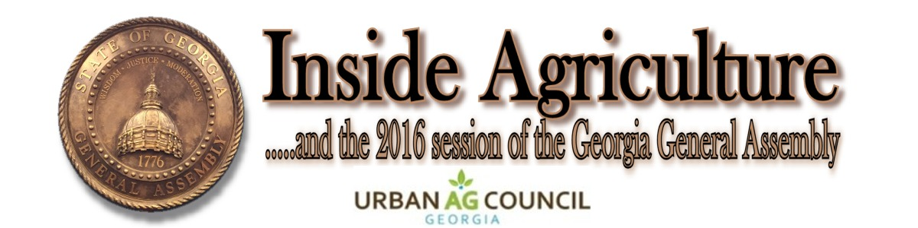

Volume 25, No. 6 Published by the Georgia Agribusiness Council, Inc. February 19, 2016

Time is growing short as the Day 30 crossover deadline looms. Day 30 is called Crossover Day because it is the last day for bills passed in either the House or Senate and cross over for approval in the other chamber…a very important deadline. Lawmakers will head home later today and then return Monday for the 25th legislative day. Legislation can begin to move really quickly at this juncture – and you have to remember, like making sausage, making laws ain’t always pretty. Here’s an update on bills of interest:

TRUCK WEIGHTS
Tuesday, the House Transportation Committee held yet another hearing on HB 411 that would raise the truck weights and expand the hauling distance from the point of origin. Agriculture and forest industry advocates spoke in favor of the bill but lawmakers also heard much opposition from state and local government interests, among others. No vote was taken. Time is growing short this session and this is a heavy lift that may need to wait for another time.

GATE
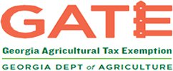
A revised version of HB 911 was passed out of House Ways and Means Sales Tax Subcommittee meeting and Friday morning. There are some favorable components to this bill, but there is still much work to be done. The revised bill still seeks the $10,000 threshold, changes the program to a three-year card (with a substantial fee increase), and adds a long list of onerous requirements on retailers. We have expressed our support for a multi-year card but we have serious concerns with the requirements being put on retailers. We will continue to work with bill sponsor Rep. Geoff Duncan to make necessary changes as the bill moves forward.

BUDGET
The FY 2017 Budget will clear the House today and then discussions on the $23.7 billion in spending. It still has a long way to go, but here are a few highlights for ag interests as it stands now. The Department of Agriculture would receive 200K for diagnostic vet labs and also 1M in bonds for State Farmers Market repairs and renovations. The Department would also pick up 500K in bonds for new vehicles. The Soil and Water Commission had some changes to their budget by eliminating ten vacant positions and also moving the One Georgia Grant funds used for the ag metering program to the Forestry Commission. The Georgia Young Farmer Programs in Atkinson and Toombs counties receive 244K. The Board of Regents would receive funding for some specialists positions: ruminant nutritionist, row crop physiologist, viticulturist and vegetable pathologist. There is also 720K in the budget for twelve extension agent positions, 650K for the Athens and Tifton Diagnostic labs, and 4M to Cooperative Extension Service and experiment stations for repairs and renovations. The agriculture experiment stations would pick up 1M to purchase new equipment and 2.5M was written in the budget for cabins at Rock Eagle. Another nice add is the veterinarian loan program, signed into law a few years ago but not funded, would receive full funding of 100K. This money would be used to support five large animal food veterinarians at 20K a year. We will keep you up to date as the budget process continues.

UAVs (Drones)
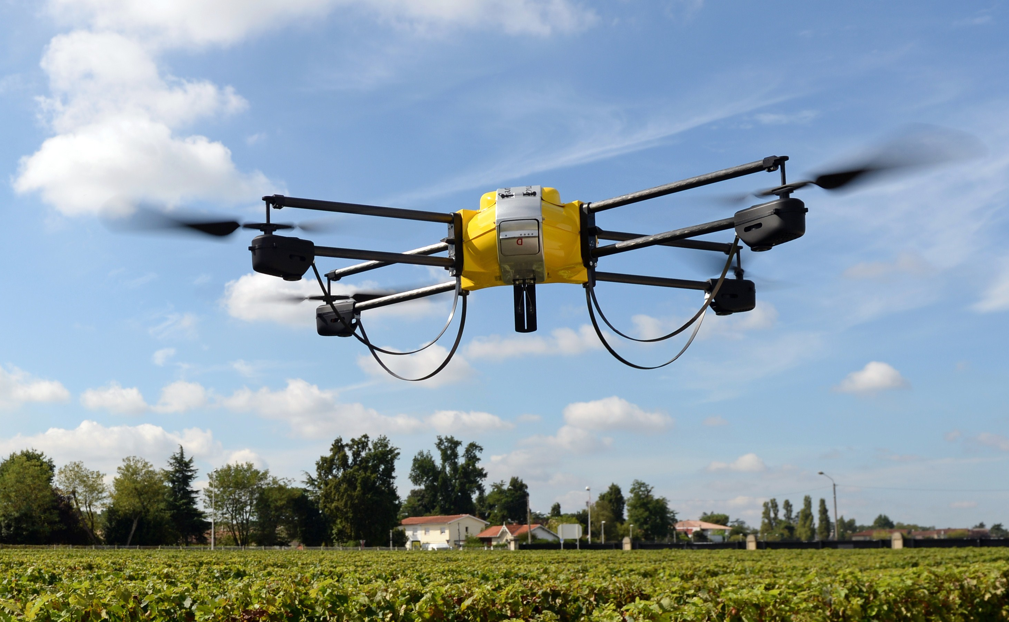
This week both bills concerning UAVs (HB 779 and SB 325) were heard in their respective committees earlier this week. No votes were taken and each of committees made it a point to say that Georgia needs to craft laws to keep up with the changing technology and remain competitive and on par with our state’s economic growth. Privacy was a large issue with HB 779, and how an expected level of privacy would be maintained. We have approached Senator Judson Hill, the sponsor of SB 325, about adding agriculture interests to the “Georgia Unmanned Aircraft Commission.” We are keeping a close eye on both bills as revisions take place.

LAND VALUATION
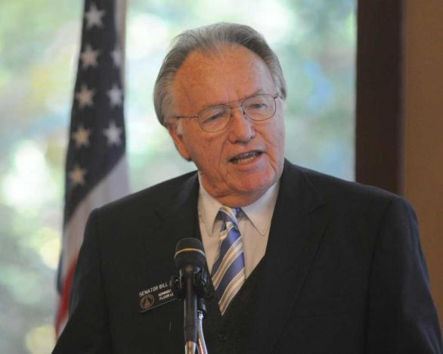
We have to be cautious when bills dealing with the Conservation Use Valuation Assessment (CUVA) are considered at the Capitol, but this SB 354 by Sen. Bill Jackson looks to be a good one. It seeks to help manage the CUVA renewal process for the property owners that are 65 or older. If the land has been in CUVA for two consecutive covenant periods, without lapse, the land would be allowed to remain in CUVA for an additional period. Should the owner die during this period, the CUVA covenant could be terminated without breach. It is scheduled to be heard in the Senate Agriculture Committee this afternoon.

SEED LAW
Rep. Sam Watson presented HB 1030, which seeks to alter the requirements for those able to be appointed to the Georgia Seed Commission. This broadens the scope of those who are eligible to be appointed so that those involved production, conditioning, or marketing of seed, turf grass, or horticultural plants are eligible. There has been great leadership from the Georgia Crop Improvement Association and UAC is proud to support the bill. It passed the House Agriculture Committee on Wednesday and we expect to see it on the House floor in the coming days.

ENVIRONMENTAL STEWARDSHIP
HB 966 is a “Waters of the U.S. (WOTUS) like bill” introduced two weeks ago. It seeks to add a definition of “ordinary high water mark” that would move the required 25ft state buffer on most streams from the normal level of water flow to the highest possible level. This action would grow the buffer width and take land out of production or use, in addition to building the case for litigation. It is likely to be heard in the House Natural Resources Committee next week and we will join with other groups to speak in opposition. We will continue to work with agriculture allies to ensure this bill gains no traction.

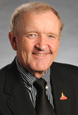
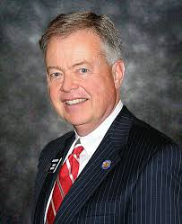
Even with legislation like HB 966 being proposed, our allies, House Ag Committee Chairman Tom McCall and Senate Ag Committee Chairman John Wilkinson have drafted resolutions, HR 1343 and SR 1018, in their respective chambers that continue to stress the repeal of WOTUS which has been litigated and repealed at every level of government except at the national level as federal bureaucrats push for these regulations. We thank Chairman McCall and Chairman Wilkinson for their efforts to continue to fight EPA and their land grabbing agenda. We look forward to supporting these resolutions in the weeks ahead and send yet another signal to EPA that their WOTUS regs are just another government overreach and we need to “ditch the rule.” Stay tuned…

*Please join us for the UAC GALA Celebration February 23, 2016. It will be held at Magnolia Hall in Piedmont Park in Atlanta, GA. For ticket details click here.
GRAPEVINE

* February 23 is FFA Day at the Capitol. We always look forward to seeing the Capitol halls filled with FFA leaders from all over the state!

*Mark your calendars for Thursday-Friday, March 17-18 for the "World of Landscape" Workforce Development Student Career Expo, sponsored by CEFGA. UAC's 2nd annual outreach to expose middle and high school students to careers in our industry. Please click here for details and contact us today to find out how you can get involved. Act NOW to become a major sponsor of this event and interact with students - your future employees!

*The UAC Networking and Education Dinner will be held March 22, 2016 at the Chattahoochee Nature Center. Join us for great networking, delicious food, and insight to the future of your business. For registration information please click here.

* Please join us Tuesday, April 19 at the UAC Networking & Education Dinner
"Right Plant Right Place Right Now: 5 easy tips for strong designs and stronger profits" - Eric King, King Landscaping, sponsored by Topiary Courtyard.
At Topiary Courtyard. Check our website for more information.

* Nominations for the CAES Alumni Association's Awards are now open. These awards recognize alumni who have made significant contributions and have achieved excellence in their chosen field and/or in their community. Click here for nomination form.

Questions? Call Mary Kay Woodworth 770-359-7337 or email mkw@georgiauac.com

This information is intended for members of the Georgia Urban Agriculture Council as a service of the Georgia Agribusiness Council, Inc. No part of this document shall be copied, edited, or redistributed in any form without express written consent from the Georgia Agribusiness Council, Inc.
www.ga-agribusiness.org

